Importing the ESRI Shape Files into Meerkat

V1.0a

Prerequisites:

* Copy of SharpGIS shp2sql v 1.3.0 or later <http://www.sharpgis.net/file.axd?file=SqlSpatialTools_build3759.zip>
* Use the \Meerkat\Data\Kenya GIS Data\kenya-election-data-master\output\counties.shp file
* SQL Server Management Studio

Process:

1. Run the Shp2SQL.exe tool
2. Select the Shape File

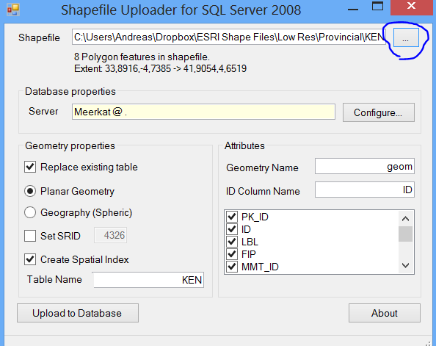

1. Click the configure button and connect to the Meerkat Database

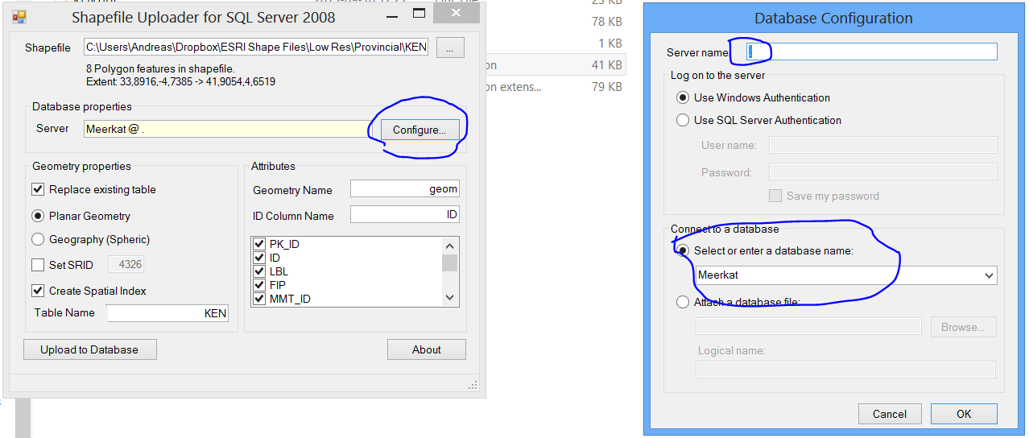

1. Set The Geometry properties as displayed in section 1 of the Image (Table Name must be ***“DimMunicipalityGEOM”***

***SRID Must be 4326***

1. Set The Attributes as displayed in Section 2 of the Image

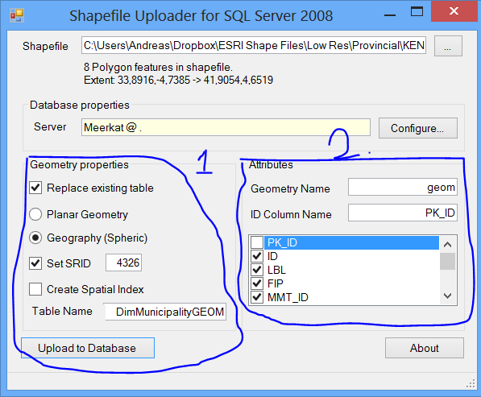

1. Clear the Checkbox for the PK_ID column
2. Click the Upload to Database button
3. Open SSMS and run the following Command

Truncate Table [Meerkat].[Core].[DimMunicipalityGEOM]

GO

SET IDENTITY_INSERT [Meerkat].[Core].[DimMunicipalityGEOM] ON

GO

Insert Into [Meerkat].[Core].[DimMunicipalityGEOM]

([PK_ID]

,[ID]

,[LBL]

,[FIP]

,[MMT_ID]

,[SHORT__FRM]

,[LONG_FRM]

,[ADM0]

,[ADM1]

,[ADM2]

,[ADM3]

,[ADM4]

,[ADM5]

,[geom])

SELECT [PK_ID]

,[ID]

,[LBL]

,[FIP]

,[MMT_ID]

,[SHORT__FRM]

,[LONG_FRM]

,[ADM0]

,[ADM1]

,[ADM2]

,[ADM3]

,[ADM4]

,[ADM5]

,[geom]

FROM [Meerkat].[dbo].[DimMunicipalityGEOM]

SET IDENTITY_INSERT [Meerkat].[Core].[DimMunicipalityGEOM] OFF

GO

Drop Table [Meerkat].[dbo].[DimMunicipalityGEOM]

go